LAB Manual

PART A

(PART A : TO BE REFFERED BY STUDENTS)

**Experiment No.09**

**A.1 Aim:**

Write a program to apply following morphological operations on finger print image.

1. Opening
2. Opening followed by closing

**A.2 Prerequisite:**

1 Matlab programming syntax (Refer the Matlab manual).

2. Knowledge of fundamentals of morphological operations.

2. Availability of Soft copy of finger print image.

**A.3 Outcome:**

**After successful completion of this experiment students will be able to**

1. Apply Opening and closing operations on given image.
2. Differentiate the outputs of different methods of opening and closing.
3. Identify applications of morphological operations studied.

**A.4 Theory:**

**A.4.1. Morphological operations**

**Morphological operations**

**1. Dilation**





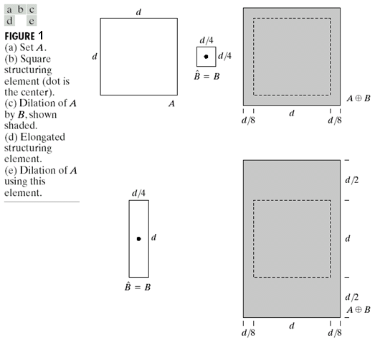

**2. Erosion**

Erosion can be defined as:

…… Eq (2)

E= {z| (B)z subset of A}

For example:

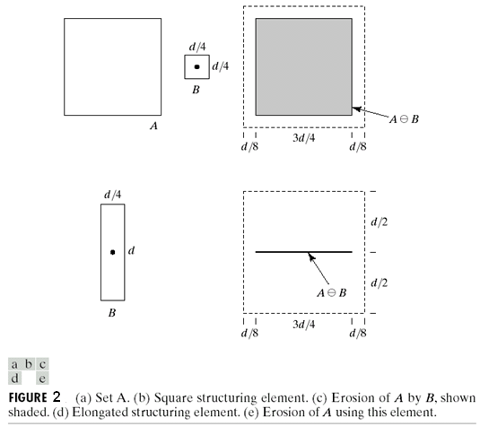

The figure is taken from Text book: “The fundamentals of Image processing” by Gonzalez Woods

**3. Opening:**

Opening is defined as

A ○ B = (A erode B) dilate B ….. Eq (3)

**4. Closing:**

Closing is defined as

A ● B = (A dilate B) erode B …… Eq (4)

**A.5 Procedure/Algorithm:**

**A.5.1:**

**TASK 1:**

1. Read the input finger print image.

2. Apply morphological operations following order and obtain 4 outputs

Separately.

1. Opening
2. Closing
3. Opening followed by closing.
4. Closing followed by opening

3. Display the original and the output images.

4. Observe/compare all outputs and complete PART B of lab manual.

5. Save and close the file and name it as **EX9_Task1_your Roll no.m**

**********************

PART B

(PART B : TO BE COMPLETED BY STUDENTS)

***(Students must submit the soft copy as per following segments within two hours of the practical. The soft copy must be uploaded on the Blackboard or emailed to the concerned lab in charge faculties at the end of the practical in case the there is no Black board access available)***

|  |  |
| --- | --- |
| Roll No.: N049 | Name: Tarun Tanmay |
| Class: MBATech CE | Batch: B3 |
| Date of Experiment: 03/09/2020 | Date of Submission 03-09-2020 |
| Grade: | Time of Submission: |
| Date of Grading: |  |

**B.1 Software Code written by student:**

clear all;

clc;

clear;

clc;

img=imread('/Users/tjrox0825/Desktop/Tarun.jpg');

img=rgb2gray(img);

img=imresize(img,[256,256]);

subplot(5,2,1), imshow(img);

img=double(img);

mask=([1 1 1;1 1 1 ;1 1 1]);

% opening image

for i=2:255

for j=2:255

a=img(i-1,j-1)*mask(1,1);

b=img(i-1,j)*mask(1,2) ;

c=img(i-1,j+1)*mask(1,3);

d=img(i,j-1)*mask(2,1) ;

e=img(i,j)*mask(2,2) ;

f=img(i,j+1)*mask(2,3);

g=img(i+1,j-1)*mask(3,1);

h=img(i+1,j)*mask(3,2) ;

k=img(i+1,j+1)*mask(3,3);

open_ero(i,j)=min([a, b, c, d, e, f, g, h,k]);

end

end

[x,y]=size(open_ero);

for i=2:x-1

for j=2:y-1

a=open_ero(i-1,j-1)*mask(1,1);

b=open_ero(i-1,j)*mask(1,2) ;

c=open_ero(i-1,j+1)*mask(1,3);

d=open_ero(i,j-1)*mask(2,1) ;

e=open_ero(i,j)*mask(2,2) ;

f=open_ero(i,j+1)*mask(2,3);

g=open_ero(i+1,j-1)*mask(3,1);

h=open_ero(i+1,j)*mask(3,2) ;

k=open_ero(i+1,j+1)*mask(3,3);

open_dil(i,j)=max([a,b,c,d,e,f,g,h,k]);

end

end

% closing image

for i=2:255

for j=2:255

a=img(i-1,j-1)*mask(1,1);

b=img(i-1,j)*mask(1,2) ;

c=img(i-1,j+1)*mask(1,3);

d=img(i,j-1)*mask(2,1) ;

e=img(i,j)*mask(2,2) ;

f=img(i,j+1)*mask(2,3);

g=img(i+1,j-1)*mask(3,1);

h=img(i+1,j)*mask(3,2) ;

k=img(i+1,j+1)*mask(3,3);

close_dil(i,j)=max([a, b, c, d, e, f, g, h,k]);

end

end

[x,y]=size(close_dil);

for i=2:x-1

for j=2:y-1

a=close_dil(i-1,j-1)*mask(1,1);

b=close_dil(i-1,j)*mask(1,2) ;

c=close_dil(i-1,j+1)*mask(1,3);

d=close_dil(i,j-1)*mask(2,1) ;

e=close_dil(i,j)*mask(2,2) ;

f=close_dil(i,j+1)*mask(2,3);

g=close_dil(i+1,j-1)*mask(3,1);

h=close_dil(i+1,j)*mask(3,2) ;

k=close_dil(i+1,j+1)*mask(3,3);

close_ero(i,j)=min([a,b,c,d,e,f,g,h,k]);

end

end

% open followed by closing

for i=2:255

for j=2:255

a=img(i-1,j-1)*mask(1,1);

b=img(i-1,j)*mask(1,2) ;

c=img(i-1,j+1)*mask(1,3);

d=img(i,j-1)*mask(2,1) ;

e=img(i,j)*mask(2,2) ;

f=img(i,j+1)*mask(2,3);

g=img(i+1,j-1)*mask(3,1);

h=img(i+1,j)*mask(3,2) ;

k=img(i+1,j+1)*mask(3,3);

open_close_ero(i,j)=max([a, b, c, d, e, f, g, h,k]);

end

end

[x,y]=size(open_close_ero);

for i=2:x-1

for j=2:y-1

a=open_close_ero(i-1,j-1)*mask(1,1);

b=open_close_ero(i-1,j)*mask(1,2) ;

c=open_close_ero(i-1,j+1)*mask(1,3);

d=open_close_ero(i,j-1)*mask(2,1) ;

e=open_close_ero(i,j)*mask(2,2) ;

f=open_close_ero(i,j+1)*mask(2,3);

g=open_close_ero(i+1,j-1)*mask(3,1);

h=open_close_ero(i+1,j)*mask(3,2) ;

k=open_close_ero(i+1,j+1)*mask(3,3);

open_close_dil(i,j)=min([a,b,c,d,e,f,g,h,k]);

end

end

% close followed by open

[x,y]=size(close_ero);

for i=2:x-1

for j=2:y-1

a=close_ero(i-1,j-1)*mask(1,1);

b=close_ero(i-1,j)*mask(1,2) ;

c=close_ero(i-1,j+1)*mask(1,3);

d=close_ero(i,j-1)*mask(2,1) ;

e=close_ero(i,j)*mask(2,2) ;

f=close_ero(i,j+1)*mask(2,3);

g=close_ero(i+1,j-1)*mask(3,1);

h=close_ero(i+1,j)*mask(3,2) ;

k=close_ero(i+1,j+1)*mask(3,3);

close_open_ero(i,j)=min([a, b, c, d, e, f, g, h,k]);

end

end

[x,y]=size(close_open_ero);

for i=2:x-1

for j=2:y-1

a=close_open_ero(i-1,j-1)*mask(1,1);

b=close_open_ero(i-1,j)*mask(1,2) ;

c=close_open_ero(i-1,j+1)*mask(1,3);

d=close_open_ero(i,j-1)*mask(2,1) ;

e=close_open_ero(i,j)*mask(2,2) ;

f=close_open_ero(i,j+1)*mask(2,3);

g=close_open_ero(i+1,j-1)*mask(3,1);

h=close_open_ero(i+1,j)*mask(3,2) ;

k=close_open_ero(i+1,j+1)*mask(3,3);

close_open_dil(i,j)=max([a,b,c,d,e,f,g,h,k]);

end

end

img=uint8(img);

open_ero=uint8(open_ero);

open_dil=uint8(open_dil);

close_dil=uint8(close_dil);

close_ero=uint8(close_ero);

open_close_ero=uint8(open_close_ero);

close_open_dil=uint8(close_open_dil);

figure('name','EXPERIMENT 9');

subplot(4,3,1),imshow(img),title('Original');

subplot(4,3,2),imshow(open_ero),title('Eroded');

subplot(4,3,3),imshow(open_dil),title('Open');

subplot(4,3,4),imshow(img),title('Original');

subplot(4,3,5),imshow(close_dil),title('Dialted');

subplot(4,3,6),imshow(close_ero),title('Close');

subplot(4,3,7),imshow(img),title('Original');

subplot(4,3,8),imshow(open_dil),title('Open');

subplot(4,3,9),imshow(open_close_ero),title('Open->Close');

subplot(4,3,10),imshow(img),title('Original');

subplot(4,3,11),imshow(close_ero),title('Close');

subplot(4,3,12),imshow(close_open_dil),title('Close->Open');

**B.2 Input and Output:**

***(Paste your program input and output in following format, If there is error then paste the specific error in the output part. In case of error with due permission of the faculty extension can be given to submit the error free code with output in due course of time. Students will be graded accordingly.)***

**Input Images:**

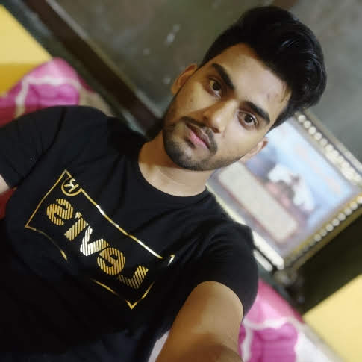

**Output Images:**

1. **For each edge detection operatoras per the procedure discussed in section A.5.**

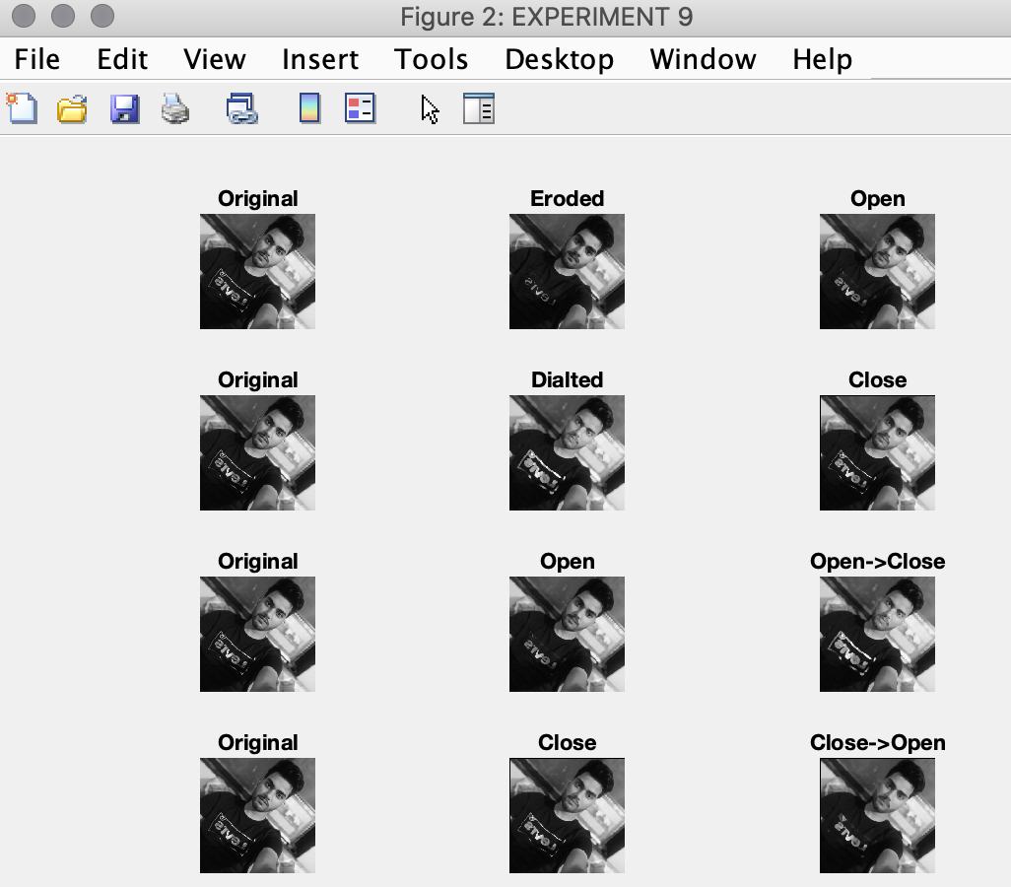

**B.3 Observations and learning:**

In the above experiment, we learnt how to apply Opening and closing operations on given image using erosion and dilation.

**B.4 Conclusion:**

After the successful implementation of the experiment, we were able to differentiate the outputs of different methods of opening and closingand were able to identify applications of morphological operations studied.

**B.5 Question of Curiosity**

List out real life applications of morphological operations.

* Visual inspection of image processing allows the user to see how the structure image affects the original image.
* Variable playback speeds allow the user to control the speed at which the structure image is processed through the image so a user can see how it affects the final image.
* User defined structure image lets the user control what the 3x3 structure image looks like and allows users the ability to see how different structure images affect different images.
* User defined images lets the user define an image up to 16x16. By clicking on the different cells, a user can setup up an image to their specifications before processing.
* Rewind functionality enables a user to revert back to the original image if multiple passes were made during image processing (such as during opening and closing).

************************